NAME OF PROJECT

INSURANCE CLAIM FRAUD DETECTION

| |
| |
| |
| |
| |

SUBMITTED BY

PANKAJ ADHIKARI

1. INTRODUCTION
In the Insurance Industry Insurance Claim Fraud has become a major issue. Due to this every years the Insurance companies suffer a tremendous loss. This type of fraud is generally hard to detect and it takes a lot of manpower to investigate for the possibility of fraud. This data set consists of the Claim Fraud for Vehicular Insurance previously detected. It shows the Fraud reported as ‘Y’ or ‘N’.

2. PROBLEM DEFINITION
In this project the fraud is of Vehicle Insurance Claim has the data of various attributes that contributes to the factors. Inspite of having all the variables we are still unable to determine fraud just by observing the factors. Hence in this case we use Data Science tools to analyse the data to predict the outcome.

3. DATA ANALYSIS
Importing of Libraries
Here we Import the important libraries as shown below
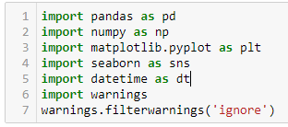

Loading of Data in DataFrame
Output
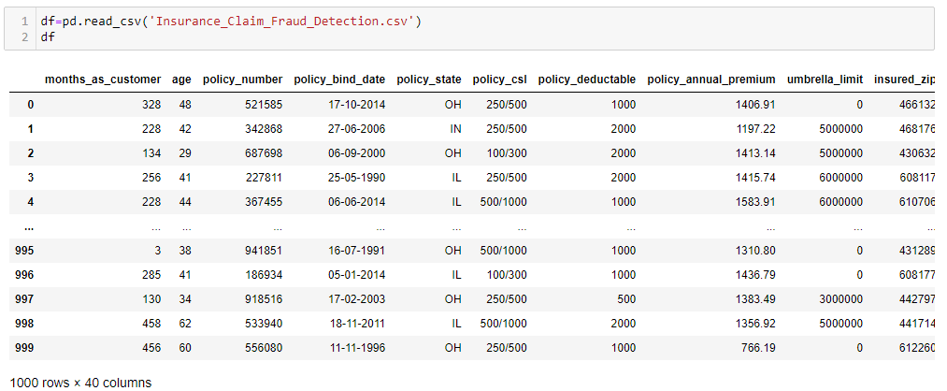
– After Loading the Data set in Data Frame we see that the data have 1000 Rows and 40 Columns

Important Attributes
df Describe()

Here we check the important attributes of Columns such as mean, count, Standard Deviation, 25-50-75 percentile, minumum , maximum values.
Output
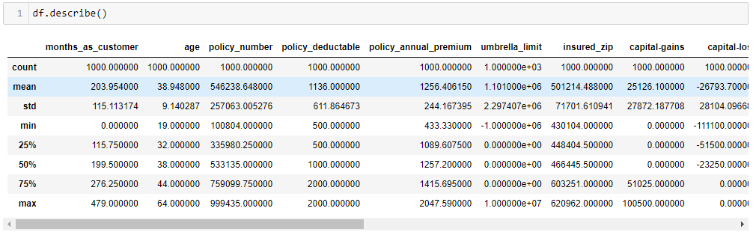
– In the above output we see variance in mean and 50% of the data which signifies presence of Outliers and data is skewed.

Describe Heat Map
Output
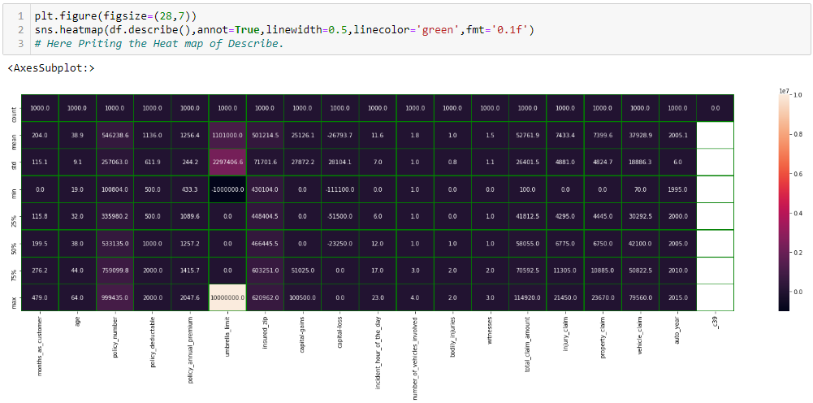
Fig : Heat map of df.describe()

Information of Columns

df.info()
– This will show us the information on data Type and Null Count.
– The data has no null or missing value
– Number of rows shown is 1000
– Column ‘_c39’ has no value in it
– After careful observation we can see that some of the values has ‘?’

Dropping of Column _c39
df.drop(‘_c39’)
As this column has no value we have drop it.

Replacing ‘?’ with Mode of the column
Output
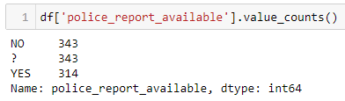
– In column ‘collision_type’ we can see that ‘?’ has 343 count. Hence we replace 50% of ‘?’ with Yes and 50% with NO.
– In column ‘police_report_available’ we can see that ‘?’ has 343 count. Hence we replace 50% of ‘?’ with Yes and 50% with NO as shown in output below.

Output
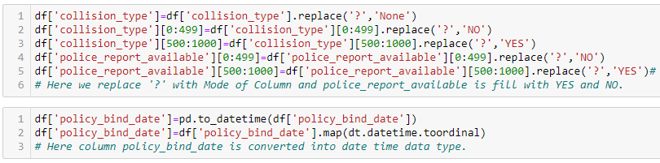
– In below Output column policy_bind_date is converted into date time data type.

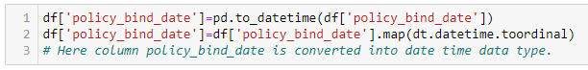

Skewness of Columns
Output
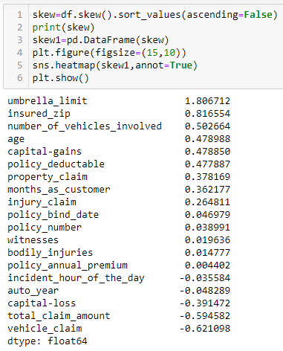
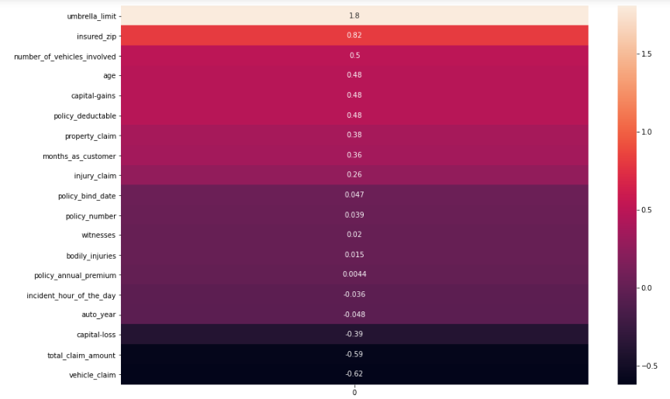
– In the above Skewness arranged in descending order, we can see that umbrella_limit has the highest skewness of 1.806712 while vehicle_claim has the lowest skewness of -0.621098.

Correlation Heatmap
Output
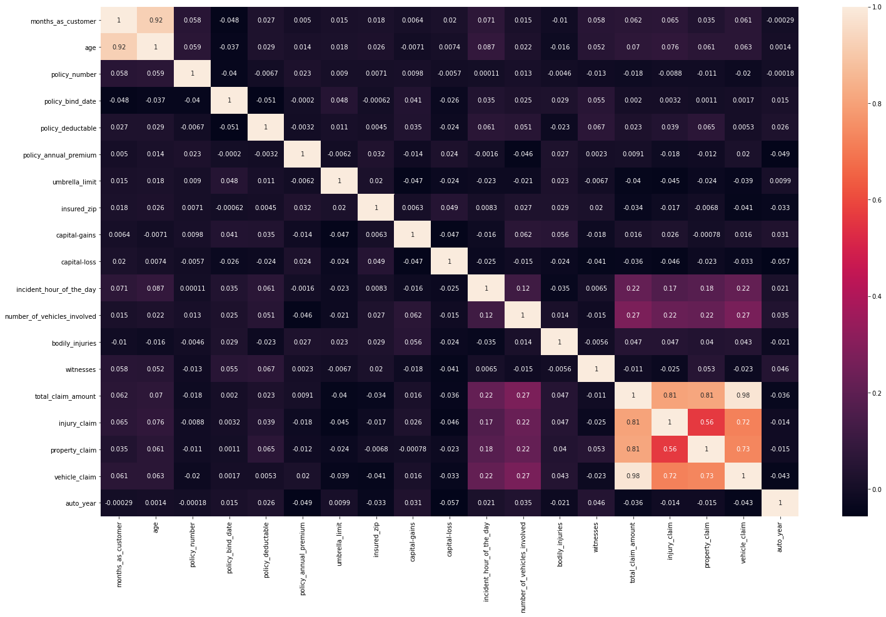
– The above correlation Heat map has high correlation between total claim amount and vehicle claim of 0.98
– Also there is high correlation between total claim amount and injury claim of 0.81
– The correlation is lowest between policy deductable and policy bind date at -0.051

Plots and Graphs

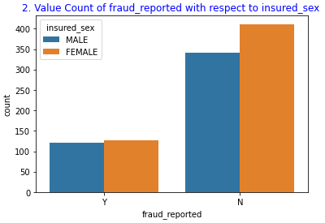
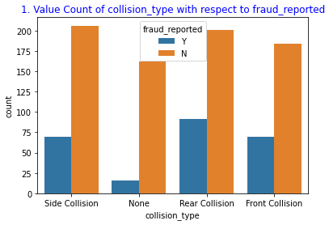
Plot-1
– It shows Side Collision being the highest with fraud reported as ‘N’ as high.
– It shows fraud reported being high among Rear Collision.
Plot-2
– It shows fraud reported as high at ‘N’
– Its shows Female Insured sex have high fraud report.

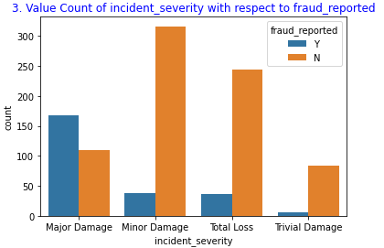
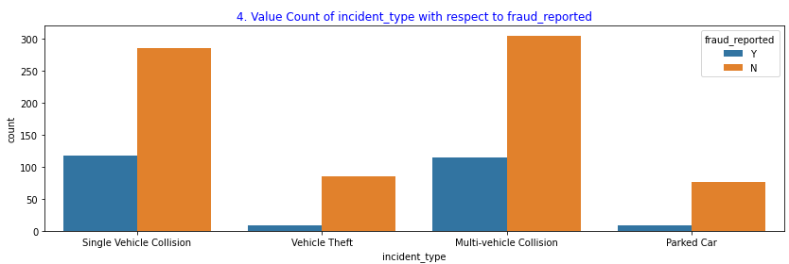
Plot-3
– It shows Minor Damage as high among incident severity
– Trival Damage has low incident severity
– Fraud reported is highest in Major Damage.
Plot-4
– It shows multivehicle collision to be highest among incident type.
– Fraud reported ih highest in Single Vehicle collision

Value Count of auto make with respect to incident type

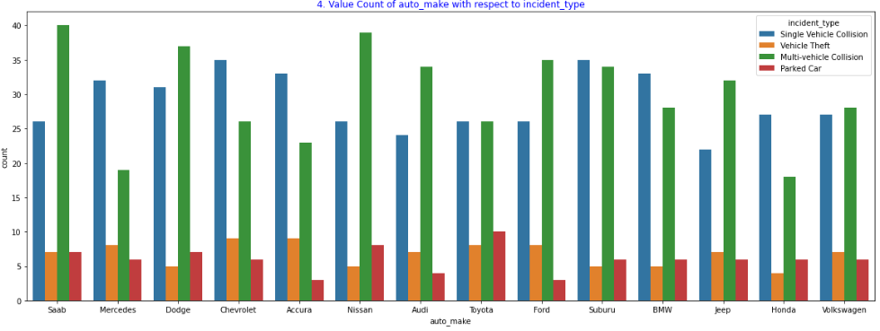
– In Count plot of auto make we see that auto make Saab has highest value count.
– ‘Saab’ auto make has high incident type of Multi-vehicle Collision.
– ‘Toyota’ auto make has highest incident type of Parked Car.
– Both Chevrolet and Accura has highest incident type of Vehicle Theft.

Value Count of Age with respect to incident type

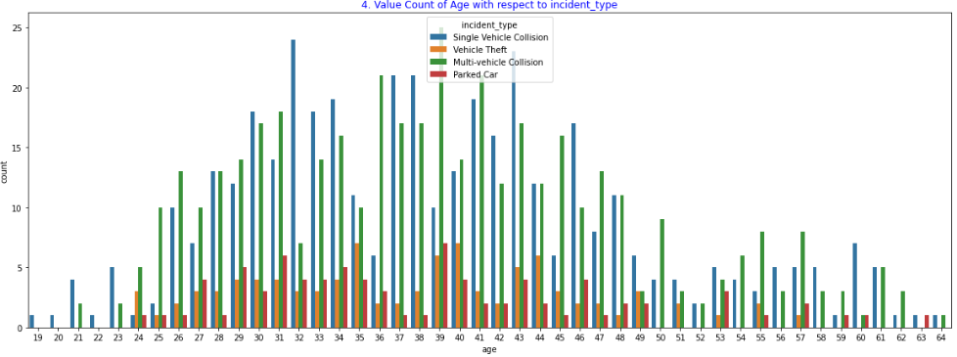
– 32 Age have the highest incident type of Single Vehicle Collision
– 39 Age have the highest incident type of Mutilvehicle Collision
– 39 Age have the highest incident type of Parked car.
– 35 Age have the highest incident type of Vehicle Theft.

Comparision between Vehicle Claim and Total Claim Amount

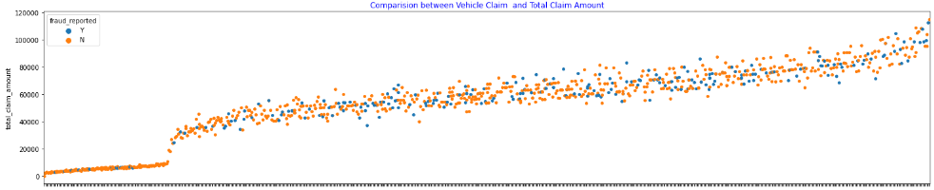
– In this we see that the graphs is positively related
– We see that below 2000 Total Claim Amount Fraud Reported is very low.

Comparision between Property Claim and Total Claim Amount
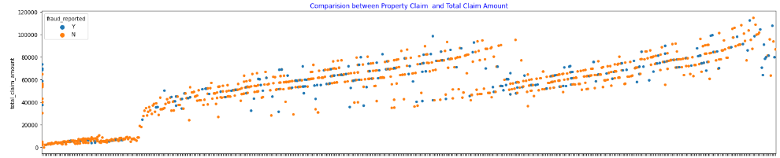
– In this we see that the graphs is positively related
– We see that below 2000 Total Claim Amount Fraud Reported is very low.

Comparision between number_of_vehicles_involved and policy_annual_premium

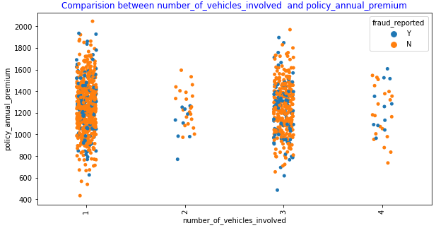
– Here we have ‘1’ number of vehicles involved has the highest count
– Policy annual premium is highest at ‘1’ and also lowest at ‘1’
– ‘2’ number of vehicles involved has the lowest count

Violin Plot of total_claim_amount

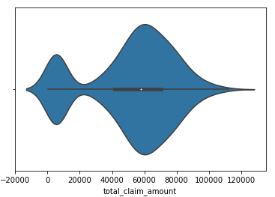
– In the above violin plot we can see that count is highest at total claim amount of 60000

Label Encoding Columns
Output
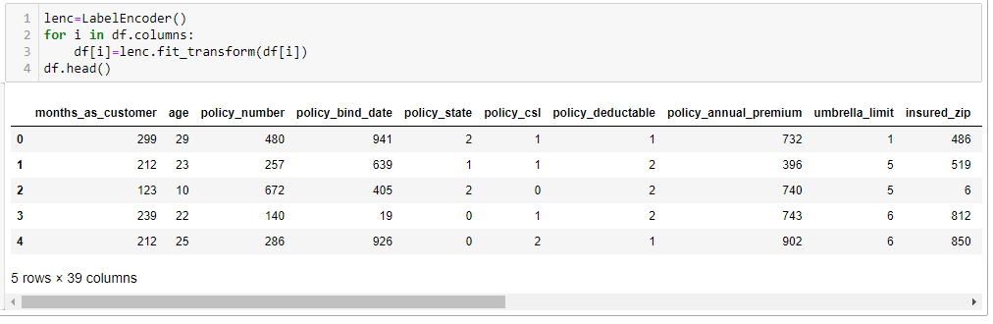
– Here we use Label Encoding to the columns and to convert the string into numerical for better evaluation and precision.
4. EDA CONCLUDING REMARKS
After analysing and proper evaluation of data we have the correct data format for further processing to prediction

5. PRE-PROCESSING PIPELINE

Train, Test Split
Defining variable ‘x’ and ‘y’
Output
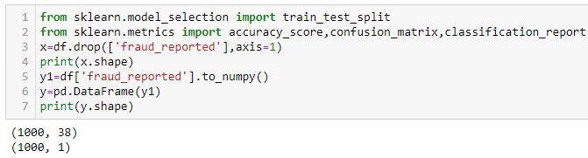
First we define the data ‘x’ and ‘y’ for prediction the data as Variable and Target. Here ‘x’ is the columns and ‘y’ is the output column.

Test Train Split
Output
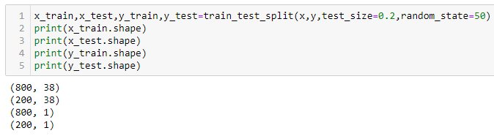
– We use Train, Test, Split to ‘x’ and ‘y’ into x_test, x_train, y_test and y_train.
– This Test Train will be use in Machine Learning Models for prediction the accuracy score.

6. BUILDING MACHINE LEARNING MODELS

Since the Target is Classified as ‘Y’ and ‘N’ we can say that the Output is Classified Type. Hence We use Classification Model to Predict the outcome. The Machine Learning models used in this project is as below along with the output of the Model.

1. Logistic Regression
Grid Search CV
The First step is to find the best parameters that will give us the best accuracy of the model. This parameters are defined in the Output as shown below.
Output
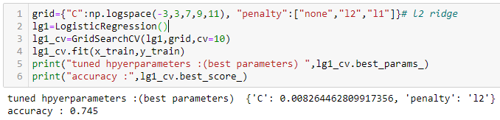
Prediction Model
In the Prediction Model we use the best parameter in the above output.
Output
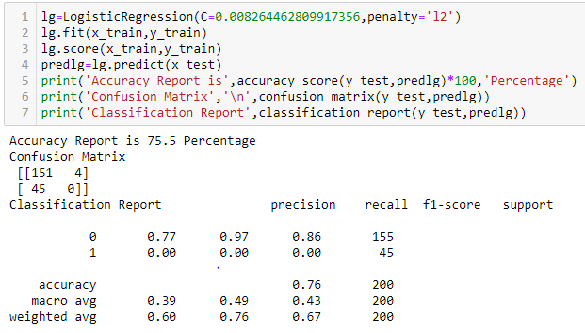
-- In the above output we see that Accuracy Report is 75% and Error is 49

Heatmap of Confusion Matrix
Output
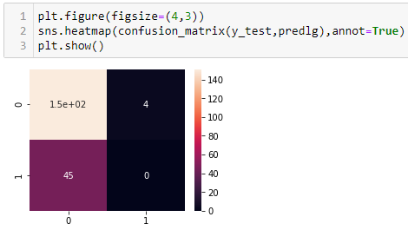

2. Decision Tree Classifier
Grid Search CV
The best parameters for Decision Tree Classfier is defined in the Output as shown below.
Output
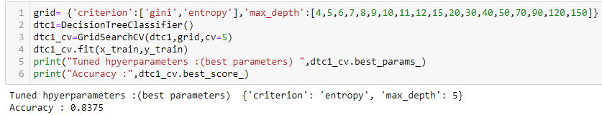
Prediction Model
In the Prediction Model we use the best parameter in the above output.
Output
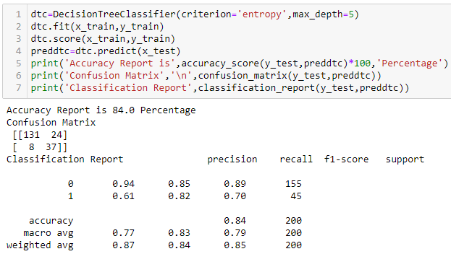

-- In the above output we see that Accuracy Report is 84% and Error is 32
Heatmap of Confusion Matrix
Output
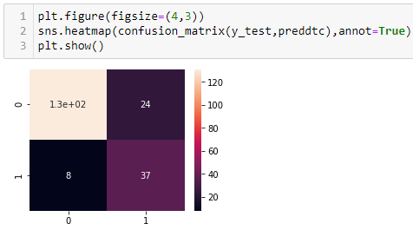

3. Support Vector Classifier
Grid Search CV
The best parameters for Support Vector Classifer is defined in the Output as shown below.
Output
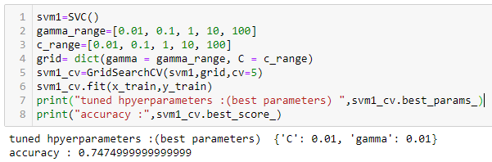
Prediction Model
In the Prediction Model we use the best parameter in the above output.
Output
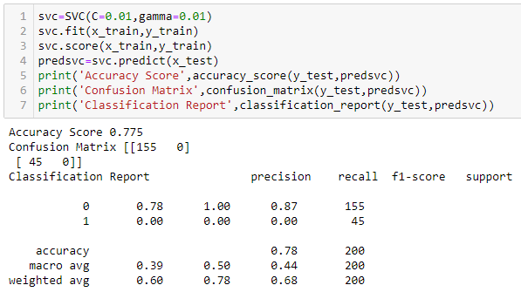
-- In the above output we see that Accuracy Report is 77% and Error is 45
Heatmap of Confusion Matrix
Output
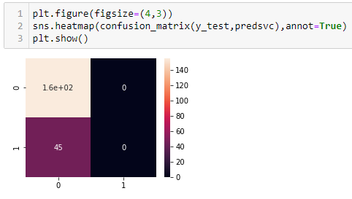

4. K-Neighbors Classifier

Train Test for K-Neighbors
– Here we have x_test x_train y_test y_train

Grid Search CV
The best parameters for Random Forest Classifier is defined in the Output as shown below.
Output
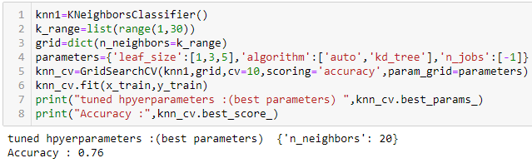
Plotting of n_neighbors with respect to accuracy
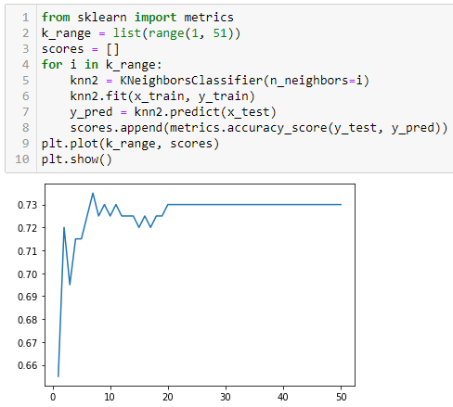
– In the above Plot we can see that the highest value of n_neighbors around 8 we have accuracy of 73%.
– The Accuracy remains constatnt after n_neighbors of 20.

Prediction Model
In this Prediction Model we have the output as below.
Output
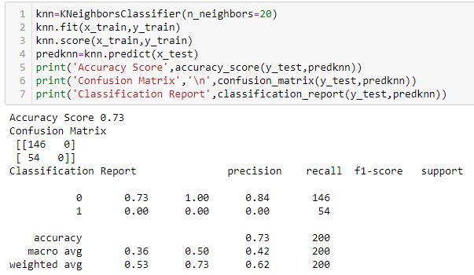
-- In the above output we see that Accuracy Report is 73% and Error is 54

Heatmap of Confusion Matrix
Output
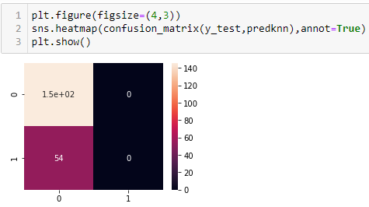

5. Random Forest Classifier

Grid Search CV
The best parameters for Random Forest Classifier is defined in the Output as shown below.
Output

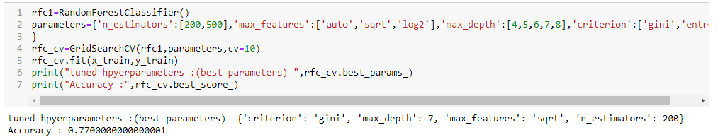
Prediction Model
In the Prediction Model we use the best parameter in the above output.
Output

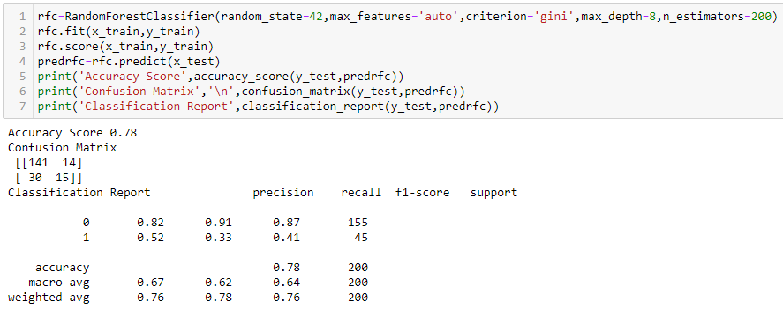
-- In the above output we see that Accuracy Report is 78% and Error is 44

Heatmap of Confusion Matrix
Output
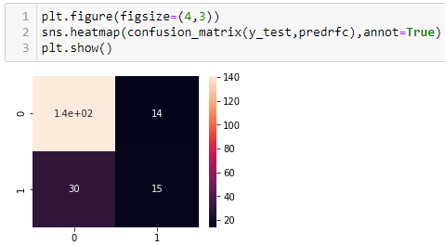

6. AdaBoost Classifier
Prediction Model
In this Prediction Model we have the output as below.
Output
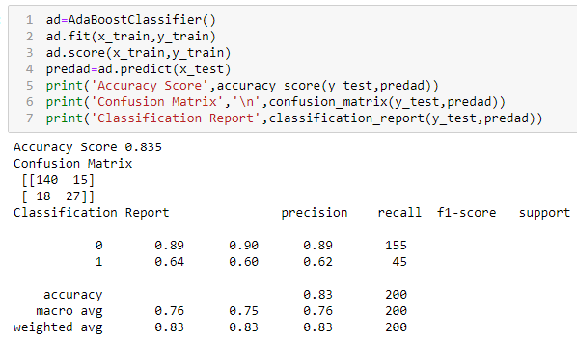
-- In the above output we see that Accuracy Report is 83% and Error is 33

Heatmap of Confusion Matrix
Output
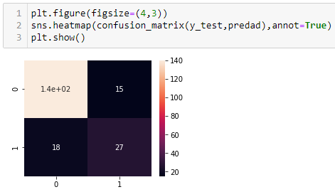

Cross Validation Score
The Cross Validation Score help us analyse which Model give us the actual accuracy based on the predictions. The least difference of Accuracy score and mean of Cross Validation Score gives us the better accuracy. In the above models Decision Tree Classifier gives us the best result.

7.CONCLUDING REMARKS
Here Random Forest Classifier give the highest accuracy score. Hence we use rfc for Testing of Dataset.

